|  |
| --- |
| Bifurcation Analysis on the Biochemical Switches in the G1-S Transition of the Mammalian Cell Cycle  M. Huang, C. Liu  Department of Biomedical Engineering, University of Southern California |

[1]*abstract

**Motivation:** The G1-S transition of the mammalian cell cycle has been the center of many studies in cancer growth as its proper function is critical to ensure the cell divides without errors. Mathematical modeling of the body of knowledge regarding the regulatory molecules contained in this system can formulate testable hypothesis that can lead to targeted treatments for cancer.

**Results:** Our bifurcation analysis showed that the overexpression of constitutive synthesis rate of cyclin D and/or cyclin E yields in a negative shift in the threshold level of mitogenic stimulation to form a saddle node bifurcation that indicates cell proliferation and the inducing a degradation on cyclin D yielded a positive shift in the threshold level of mitogenic stimulation to form a saddle node bifurcation that indicates cell arrest (quiescence).

**Conclusion:** This suggests the use of therapeutic use of drugs that targets the inhibition of expression of cyclin D and cyclin E and/or by inducing the degradation of cyclin D to induce cell cycle arrest on cancer cells.

# introduction

The G1-S transition of cell cycling provides the go signal for DNA synthesis after the cell has grown to a sufficient stage and the requisite processes to continue into cell division have completed. Errors in this go signal have been shown to lead to uncontrolled growth of the cell - a hallmark of cancer. Thus there is a major focus to understand the molecular interactions of this regulatory system. Decades of experimental research has uncovered a range of molecules and interactions involved. Mathematical modeling is used to integrate the existing body of knowledge into a larger framework to describe experimental observations of the overall system. If successful, the model can then be reasonably used to make predictions about effects of manipulating cell regulatory molecules on cell cycling, which suggest treatments to correct cell cycling errors that lead to cancer, as well as to further scientific knowledge.

The present model of the G1-S transition by Hatzimanikatis, et al., 1999 can be characterized by a phosphorylation cascade that amplifies a transcription promoter to activate a transcription factor to bring the cell cycle into DNA synthesis - the S phase [1]. This phosphorylation cascade can be characterized as a positive feedback loop that behaves as a biochemical switch to toggle the transcription factor to a higher steady state.

While this model has been shown to replicate experimentally observed phenomena, this model only contains one transcription factor promoter, cyclin E. Much evidence demonstrates the overexpression of an additional transcription factor promoter, cyclin D, in several types of tumor formation. Cyclin D is established as an oncogene with an important pathogenetic role in many human tumors [2]. Thus, the mathematical model by Hatzimanikatis is oversimplified and demonstrates an omission of important components in the overall picture.

To overcome this limitation, we extend the model by incorporating the phosphorylation cascade involving cyclin D and its corresponding cyclin-dependent kinases, cdk4/6, as described by Swat et al., 2004. Next we determine if this model can be used to describe experimental observations of the effects of overexpressing the constitutive synthesis rates of cyclin D and cyclin E on cell proliferation and inducing degradation of cyclin D on cell arrest. If successful, it increases confidence in the model’s ability to suggest drug targets to inhibit cell proliferation, and thus stop tumorigenesis.

# Methods

## The G1/S Model Exhibits Bistability that Indicates Cell Proliferation

The mathematical model of the G1/S transition in mammalian cells is based on a previous model proposed by Swat et al. (2004) which includes a set of proteins and their regulatory gene factors. The schematic diagram of the G1/S transition network is provided in Fig. 1 and their relationships are presented as differential equations provided in the supplementary material section.

The model can be summarized by its two phosphorylation cascades involving the cyclin D, cdk4/6 complex and the cyclin E, cdk2 complex that act as biochemical switches to regulate the level of the transcription factor, E2F-1. At beginning of the cell cycle, E2F-1 is bound to the tumor suppressor (pRB). Two phosphorylation cascades represented by the two transcription factor promoters, cycD-cdk4,6, and cycE-cdk2 behaves as a positive feedback mechanism. These two positive feedback loops trigger the two stage phosphorylation of pRB to free its suppression of E2F-1. This rapidly increases E2F-1 in a switch like manner to bring it to a higher steady state, and thus committing the cell cycle into cell proliferation, the S phase. Moreover, E2F-1 will amplify

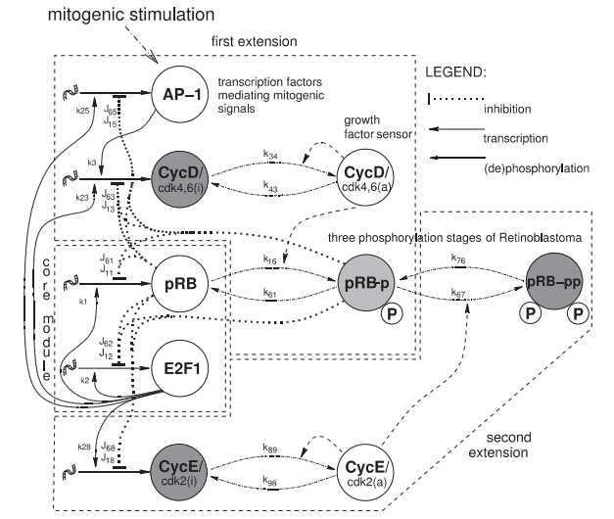

**Fig. 1** The schematic diagram of cell cycle transition from the G0-phase to S-phase [3]

the signal of the generation of cyclin D, cyclin E, and pRB and cause them to reach a higher stable steady state. The presence of two steady states in the system that toggle from a low steady state (off) to a high steady state (on) indicates bistability shown in Fig. 2.

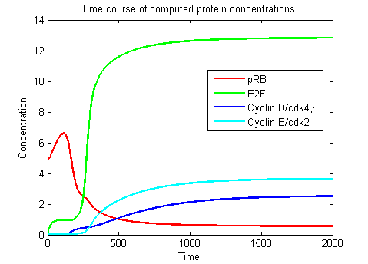

**Fig. 2** The bistable response of the transcription factor indicates switching between two steady states.

## Bifurcation Analysis of the G1/S Transition

The bifurcation analysis with the strength of the mitogenic growth signal, Fm, as a bifurcation parameter is used to determine cell proliferation. Low levels of Fm are inadequate to produce cyclin D to trigger the phosphorylation cascade shown in Fig. 3. In this case, the switching to a second steady state does not occur. As Fm increases past a threshold as indicated through a saddle node bifurcation, the system switches to generate bistability. The bifurcation diagram shown in Fig. 4 can be generated by extracting the steady state(s) out of each Fm condition by plotting d[E2F1]/dt in respect to E2F1 and choosing the points where d[E2F1]/dt=0 to obtain the steady state values.



**Fig.3.** System switches to a bistable system when a threshold value of Fm is reached. Here Fmcrit=0.0035, thus indicating a saddle node bifurcation.



**Fig. 3.** Bifurcation diagram of G1-S transition with Fm as the bifurcation parameter.

## Constitutive Synthesis Rates for Cyclin D and Cyclin E

For the model to describe experiments involving the constitutive overexpression of the synthesis rates of cyclin D and cyclin E, we added a constitutive value, CD and CE, to provide a basal rate of growth for Cyclin D and Cyclin E, respectively.

|  |  |
| --- | --- |
|  | (1) |
|  | (2) |

After the constitutive synthesis rate was added, the E2F-1 dependent rate constants were adjusted to bring the saddle node bifurcation threshold ­back to the baseline as determined by the original model from [3].

**Table 1.**Chosen parameter values for cyclin D and cyclin E synthesis rates

|  |  |  |
| --- | --- | --- |
| Parameter | Original Value | New Value |
| K28 | 0.06 | 0.04 |
| CE | 0 | 0.005 |
| K23 | 0.3 | 0.1 |
| CD | 0 | 0.002 |

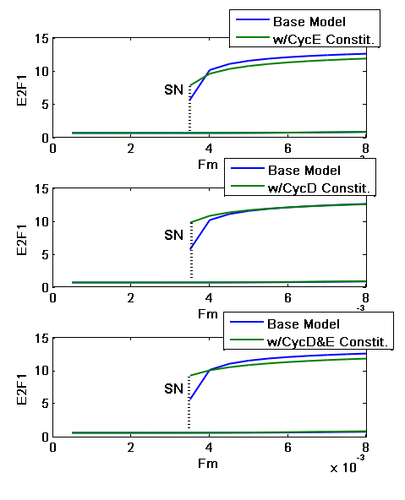

**Fig. 5. A**fter the addition of a constitutive rate, combinations of cyclin E (top) and cyclin E (middle) synthesis rate parameters adjusted so that the saddle node threshold matches original model baseline conditions. Combining the parameters for both cyclin D and cyclin E showed the retention of the same saddle node point (bottom).

# results and discussion

## Constitutive Overexpression in the Synthesis Rates of Cyclin D and Cyclin E

By performing the bifurcation analysis on the constitutive overexpression of the synthesis rates of cyclin E, cyclin D, and both cyclin D&E, it is found that the saddle point is shifted to a smaller value of Fm shown in Fig. 6. This indicates that the higher synthesis rates of cyclin E and cyclin D brought the cell from quiescence to proliferation. This is experimentally observed where a constitutive overexpression of cloned cyclin E resulted in a transition to proliferation in serum-free medium for Chinese hamster ovary cells [5]. Additionally, overexpression of cyclin D1 in rat embryo fibroblasts is shown to shorten the G1 phase by inducing a progression into the S phase [6]. For the overexpression of both cyclin D&E, the cell proliferated even more rapidly as indicated by the saddle nodes shifting even further to a smaller threshold of Fm. This has been observed in a study involving RT-PCR and immunohistochemical analysis of rat esophageal tumors where both cyclin D and cyclin E mRNA levels were increased several fold greater than in normal tissue [7]. Thus it is shown that this model is in excellent agreement with experimentally observed phenomena.

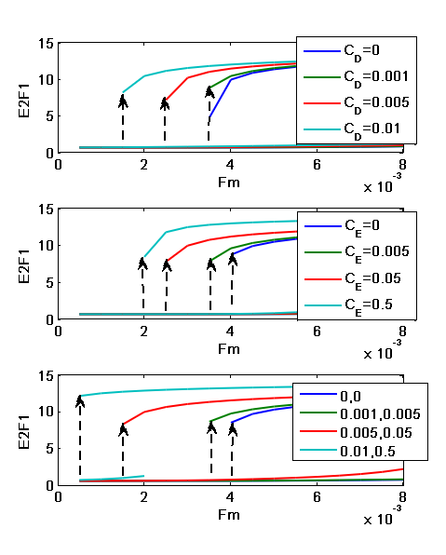

**Fig. 6. A**fter overexpressing the constitutive synthesis rates of cyclin D(top), cyclin E(middle), both (bottom). Results indicate the overexpression shifts the bifurcation to lower Fm values, indicating cell proliferation.

## Inducing degradation in Cyclin Di and Cyclin Da

Many biomolecular regulators play the role of degrading the cyclin D signal and can be a target of pharmacological therapy. A bifurcation analysis of an increase in the degradation rate of both cyclin D­I (parameter:*ϕ*CycEi) and cyclin Da (parameter:*ϕ*CycEa) led to strong cellular arrest in cells showing strong proliferation due to the overexpression of cyclin D. Indeed, the deregulated cyclin D1 degradation is shown to be present in several cancers and agents used to induce degradation of cyclin D1 have been shown to be therapeutic for the treatment of cancer [8].

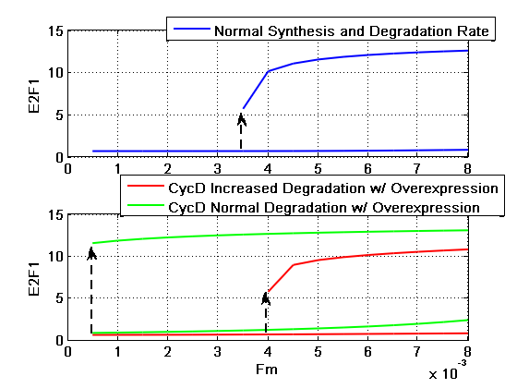

**Fig. 8** Oscillatory behavior that’s indicative of cell cycling is present after adding a negative feedback from E2F-1 to cyclin D and cyclin E.

**Fig. 7.** Inducing degradation of cyclin D arrests proliferation caused by the overexpression of cyclin D. Top: Normal synthesis and degradation of cyclin D. Bottom: Overexpressed cyclin D with normal degradation and induced degradation. ϕCycEi=0.04, ϕCycEa=0.05

## Drug targets to induce cellular arrest

Our model shows that by decreasing the synthesis rates for cyclin D and cyclin E, the cell arrest is induced. This implicates the use of drugs that block the expression of cyclin D and/or cyclin E to stop tumor growth. There are many drugs found to inhibit the expression of cyclin D including Troglitazone, Anasamycin, and Monoterpenes [9][10][11] or inhibit the expression of cyclin E [12].

## Addition of negative feedback to show cell cycle oscillations

Another indication of cell cycling is through the observation of oscillatory behavior [3] [4]. This oscillatory behavior is due to transcriptional repressors present to bring the transcriptional factor, E2F-1, back down to baseline after the cell has committed into the S-phase. This model can also be modified to show the oscillatory behavior of cell proliferation that is found in the past model by Hatzimanikatis et al. 1999. This can be done by adding an E2F-1 dependent degradation rate to free cyclin E and free cyclin D.

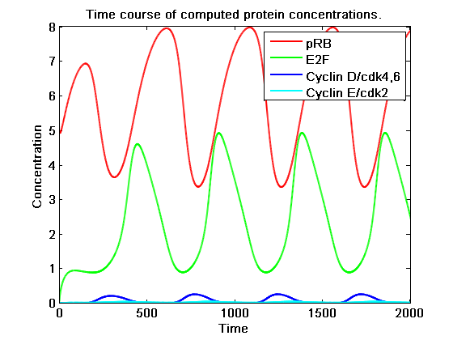

Conclusions

Based on the model proposed by Swat et al. (2004), we were able to control cell proliferation and cell arrest through both the manipulation of the synthesis and degradation rates of the biochemical switches that’s in excellent agreement with observed experimental phenomena. We also elucidate a list of pharmacological interventions to cancer therapy given our model results. Furthermore, this model provides a mathematical foundation to further study the additional parameters that control the activation and inactivation of cyclin E and cyclin D contained in this model.

acknowledgements

We thank Stacey Finley for the useful discussions into clarifying our direction with this study.

Supplementary materials

**G1S_Func**

function dydt=G1S_Func(t,y,pars)

RB = y(1);

E2F = y(2);

CycD = y(3);

CycD_a = y(4);

AP = y(5);

RB1 = y(6);

RB2 = y(7);

CycE = y(8);

CycE_a = y(9);

k1 = pars(1);

k2 = pars(2);

k3 = pars(3);

k16 = pars(4);

k34 = pars(5);

k43 = pars(6);

k61 = pars(7);

k67 = pars(8);

k76 = pars(9);

k23 = pars(10);

k25 = pars(11);

k28 = pars(12);

k89 = pars(13);

k98 = pars(14);

a = pars(15);

J11 = pars(16);

J12 = pars(17);

J15 = pars(18);

J18 = pars(19);

J61 = pars(20);

J62 = pars(21);

J65 = pars(22);

J68 = pars(23);

J13 = pars(24);

J63 = pars(25);

Km1 = pars(26);

Km2 = pars(27);

Km4 = pars(28);

Km9 = pars(29);

kp = pars(30);

phi_RB = pars(31);

phi_E2F = pars(32);

phi_CycD = pars(33);

phi_CycD_a = pars(34);

phi_AP = pars(35);

phi_RB1 = pars(36);

phi_RB2 = pars(37);

phi_CycE = pars(38);

phi_CycE_a = pars(39);

Fm = pars(40);

C=pars(41); %Constitutive Term

dydt(1,1) = k1*E2F*J11*J61/((Km1+E2F)*(J11+RB)*(J61+RB1))-k16*RB*CycD_a+k61*RB1-phi_RB*RB;

dydt(2,1) = kp+k2*(a^2+E2F^2)*J12*J62/((Km2^2+E2F^2)*(J12+RB)*(J62+RB1))-phi_E2F*E2F;

dydt(3,1) = k3*AP+k23*E2F*J13*J63/((J13+RB)*(J63+RB1))+k43*CycD_a-k34*CycD*CycD_a/(Km4+CycD_a)-phi_CycD*CycD;

dydt(4,1) = k34*CycD*CycD_a/(Km4+CycD_a)-k43*CycD_a-phi_CycD_a*CycD_a;

dydt(5,1) = Fm + k25*E2F*J15*J65/((J15+RB)*(J65+RB1))-phi_AP*AP;

dydt(6,1) = k16*RB*CycD_a-k61*RB1-k67*RB1*CycE_a+k76*RB2-phi_RB1*RB1;

dydt(7,1) = k67*RB1*CycE_a-k76*RB2-phi_RB2*RB2;

dydt(8,1) = C+k28*E2F*J18*J68/((J18+RB)*(J68+RB1))+k98*CycE_a-k89*CycE*CycE_a/(Km9+CycE_a)-phi_CycE*CycE;

dydt(9,1) = k89*CycE*CycE_a/(Km9+CycE_a)-k98*CycE_a-phi_CycE_a*CycE_a;

end

**G1S_Drive_Bifurcation**

clc

clear all;

close all;

tspan = 0:1:1000;

%k1 k2 k3 k16 k34 k43 k61 k67 k76 k23 k25 k28 k89 k98 a

k=[1 1.6 0.05 0.4 0.04 0.01 0.30 0.7 0.1 0.3 0.9 0.06 0.07 0.01 0.04];

%J11 J12 J15 J18 J61 J62 J65 J68 J13 J63

J=[0.5 5.00 0.001 0.6 5.0 8.0 6.0 7 0.002 2.0];

%Km1 Km2 Km4 Km9 kp

Km=[0.5 4.0 0.3 0.005 0.05];

%phiRB phiE2F phicycD phicycDa phiAP phiPRBp phiPRBpp phiCycE phiCyca Fm

phi=[0.005 0.1 0.02300 0.030000 0.0100 0.06000 0.040000 0.06000 0.05000 0.044];

C=0;

pars = [k J Km phi C];

initial = [5 0 0 0.01 0 0 0 0 0.01];

figure;

%Solve for ODE at different Fm

for i=1:16

pars(40)=i*0.0005;

options = odeset('reltol',1e-6);

[t,result{i}]=ode45(@G1S_Func,tspan,initial,options,pars);

subplot(4,4,i);plot(t,result{i}); axis([0 1000 0 15]);

end

r1=result{1};r2=result{2};r3=result{3};r4=result{4};r5=result{5};

r6=result{6};r7=result{7};r8=result{8};r9=result{9};r10=result{10};

r11=result{11};r12=result{12};r13=result{13};r14=result{14};r15=result{15};r16=result{16};

Stability_Low=[r1(200,2),r2(200,2),r3(200,2),r4(200,2),r5(200,2),r6(200,2),r7(200,2),r8(200,2),r9(200,2),r10(200,2),r11(200,2),r12(200,2),r13(200,2),r14(200,2),r15(200,2),r16(200,2)];

Stability_High=[r1(800,2),r2(800,2),r3(800,2),r4(800,2),r5(800,2),r6(800,2),r7(800,2),r8(800,2),r9(800,2),r10(800,2),r11(800,2),r12(800,2),r13(800,2),r14(800,2),r15(800,2),r16(800,2)];

Fm=zeros(1,16);

for i=1:16

Fm(i)=i*0.0005;

end

%Constitutive Overspression of Cyclin E

C=0.2;

k(12)=0.04;

pars = [k J Km phi C];

figure;

for i=1:16

pars(40)=i*0.0005;

options = odeset('reltol',1e-6);

[t,result{i}]=ode45(@G1S_Func,tspan,initial,options,pars);

subplot(4,4,i);plot(t,result{i}); axis([0 1000 0 15]);

end

r1=result{1};r2=result{2};r3=result{3};r4=result{4};r5=result{5};

r6=result{6};r7=result{7};r8=result{8};r9=result{9};r10=result{10};

r11=result{11};r12=result{12};r13=result{13};r14=result{14};r15=result{15};r16=result{16};

Stability_Low1=[r1(200,2),r2(200,2),r3(200,2),r4(200,2),r5(200,2),r6(200,2),r7(200,2),r8(200,2),r9(200,2),r10(200,2),r11(200,2),r12(200,2),r13(200,2),r14(200,2),r15(200,2),r16(200,2)];

Stability_High1=[r1(800,2),r2(800,2),r3(800,2),r4(800,2),r5(800,2),r6(800,2),r7(800,2),r8(800,2),r9(800,2),r10(800,2),r11(800,2),r12(800,2),r13(800,2),r14(800,2),r15(800,2),r16(800,2)];

%Generate Bifurcation plot

figure; axis([0 0.0005*16 0 15]);

subplot(2,1,1);plot(Fm,Stability_Low,Fm(7:16),Stability_High(7:16));

xlabel('Fm');ylabel('E2F1');grid on;title('Bifurcation without Overexpression of Cyclin E')

subplot(2,1,2);plot(Fm,Stability_Low1,Fm(4:16),Stability_High1(4:16));

xlabel('Fm');ylabel('E2F1');grid on;title('Bifurcation with Overexpression of Cyclin E at C=0.2')

References

[1] Hatzimanikatis, V., Lee, K. H., & Bailey, J. E. (1999). A mathematical description of regulation of the G1‐S transition of the mammalian cell cycle. *Biotechnology and Bioengineering*, *65*, 631-637.

[2] Stamatakos, M., Palla, V., Karaiskos, I., Xiromeritis, K., Alexiou, I., Pateras, I., et al. (2010). Cell cyclins: triggering elements of cancer or not?. *World Journal of Surgical Oncology*, *8*, 111.

[3] Swat, M., Kel, A., & Herzel, H. (2004). Bifurcation analysis of the regulatory modules of the mammalian G1/S transition. *Bioinformatics*, *20*, 1506-1511.

[4] Bertoli, C., Skotheim, J. M., & Bruin, R. A. (2013). Control of cell cycle transcription during G1 and S phases. *Nature Reviews Molecular Cell Biology*, *14*(8), 518-528.

[5] Renner W, Lee KH, Hatzimanikatis V, Bailey JE, Eppenberger H. 1995. Recombinant cyclin E expression activates proliferation and obviates surface attachment of Chinese hamster ovary (CHO) cells in proteinfree medium. Biotechnol Bioeng 47:476–482

[6] Imoto, M. (1997). Effects of Cyclin D1 Overexpression on G1 Progression-Related Events. *Experimental Cell Research*, *236*(1), 173-180.

[7] Wangu, Q., Sabourin, C. L., Wang, H., & Stoner, G. D. (1996). Overexpression of cyclin D1 and cyclin E in -nitrosomethylbezylamine-induced rat esophageal tumorigenesis. Carcinogenesis, 17(8), 1583-1588.

[8] Alao, J. P. (2007). The regulation of cyclin D1 degradation: roles in cancer development and the potential for therapeutic invention. *Molecular Cancer*, *6*(1), 24.

[9] He G, Thuiller P, Fischer SM, (2004). Troglitazone inhibits cyclin D1 expression and cell cycling independently of PPARgamma in normal mouse skin keratinocytes. *J Invest Dermatol*, 2004 Dec;123(6):1110-9

[10] Bardon, S., Picard, K., & Martel, P. (1998). Monoterpenes Inhibit Cell Growth, Cell Cycle Progression, And Cyclin D1 Gene Expression In Human Breast Cancer Cell Lines. *Nutrition and Cancer*, *32*(1), 1-7.

[11] Basso, A. D., Solit, D. B., Munster, P. N., & Rosen, N. (2002). Ansamycin antibiotics inhibit Akt activation and cyclin D expression in breast cancer cells that overexpress HER2. *Oncogene*, *21*(8), 1159-1166.

[12] Koroxenidou, L., Ohlson, L., & Hallstrom, I. P. (2005). Long-term 17alpha-ethinyl estradiol treatment decreases cyclin E and cdk2 expression, reduces cdk2 kinase activity and inhibits S phase entry in regenerating rat liver. *J Hepatol*, *43*(3), 478-84.

1. * mikehuan@usc.edu , chihchi@usc.edu